Game Design Document

Fill up the following document

1. Write the title of your project.

Protect the Sword

1. What is the goal of the game?

The wizard protects the sword from the orcs.

1. Write a brief story of your game.

The wizard protects a sword that has great power. The orcs want this sword for some evl purpose,so the wizard protects it from them.

1. Which are the playing characters of this game?

* Playing characters are the ones who respond to the user based on the input from the user.
* Cars, monkeys, dinos, wizards, etc., are the playing characters in the game.

|  |  |  |
| --- | --- | --- |
| Number | Character Name | What can this character do? |
| 1 | Wizard | Can destroy orcs with fire |
| 2 |  |  |
| 3 |  |  |
| 4 |  |  |
| 5 |  |  |
| 6 |  |  |
| 7 |  |  |
| 8 |  |  |

1. Which are the Non-Playing Characters of this game?

* Non-Playing characters are the ones that don't have an action or behavior when the user interacts with the game.
* Hurdles, stones, bananas, coins, etc., are non-playing characters in the game.

|  |  |  |
| --- | --- | --- |
| Number | Character Name | What can this character do? |
| 1 | orcs | They try to take the sword |
| 2 | sword | Contains great power |
| 3 |  |  |
| 4 |  |  |
| 5 |  |  |
| 6 |  |  |
| 7 |  |  |
| 8 |  |  |

Draw your imagination of this game. What does this game look like?

* Draw the game either on your computer or on paper.
* Add images of the game scenes to show each of the playing and non-playing characters at least once.

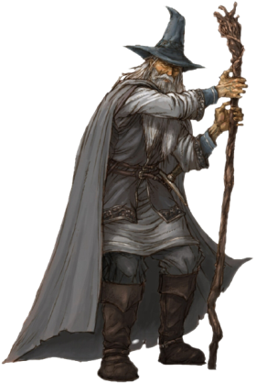D:\Aryan white hat jr\My game\p5.play-boilerplate-master\orc1.jpg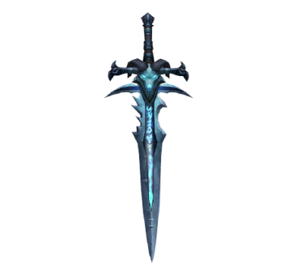

How do you plan to make your game engaging?

I plan to make my game engaging by adding game adaptivity.